EE380 Project #3 Solution fall, 2017
Due: week 9
Question 1)
----------------------------------------------------------------
From -1.0 to 1.0 to generate 2000 numbers and find mean, standard deviation, variance of these 2000 numbers, and plot histogram of these 2000 numbers. (Provide Matlab source code)

Solution
x= rand(1,2000)*2-1;
meanx=mean(x);
fprintf('Mean of x %f', meanx)
standardevx=std(x);
fprintf('Standard Deviation of x is %f', standardevx)
variance = var(x);
fprintf('Variance of x is %f', variance)
figure;
hist(x,20)

Mean of x 0.024283
Standard Deviation of x is 0.578821
Variance of x is 0.335034
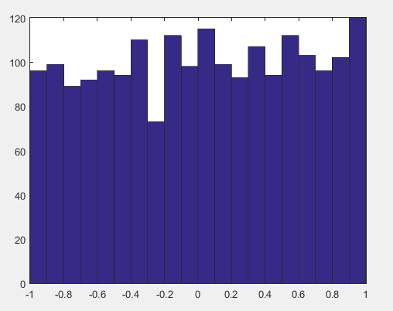

Question 2)
----------------------------------------------------------------
Using Binomial Distribution to answer the following questions:
- If a productive line has 0.2 defect rate, what is the probability to have 1 defective part of 6 randomly selected parts?
- What is the probability to have at least 3 good parts from randomly selected 10 parts? (The defect rate is 0.3).
- What is the probability to have less than 3 bad parts from 10 randomly selected parts? (The defect rate is 0.25).
To compare the results obtained from Matlab code and manual calculation through Binomial calculation.

Solution

a=binopdf(1,6,0.2)

a = 0.3932
- b=binopdf(0,10,0.7)+ binopdf(1,10,0.7)+ binopdf(2,10,0.7)+ binopdf(3,10,0.7)
b=0.0106

or b=binocdf(3,10,0.7)
b=0.0106
For only 3 good parts b=binopdf(3,10,0.7) and
b=0.0090

- c=binocdf(2,10,0.25)
c=0.5256

Question 3)

A quality control unit inspects 300 pieces products every day. If 3% of the products have defects, what is the highest number of defective products will be found?

Solution
defect=0:300;
y=binopdf(defect, 300, 0.03)
[x,i]= max(y);
fprintf(‘The maximum defects found is %f’, defect(i))
fprintf(‘The highest probability is %f’, x)

The maximum defects found is 9.0
The highest probability is 0.133776
Question 4)
---------------------------------------------------------------------
Mean is 0 and standard deviation is 1 using Matlab to generate a Normal Distribution (2000 data). To plot histogram of these 2000 data and bin is 50. Use ‘trapz’ to normalize bar chart and plot it. This is the pdf of the distribution.

Solution

clear
clc
a=randn(1,2000);
figure; hist(a,50);
title(‘Histogram’)
[f,x]=hist(a,50);
figure; bar(x,f/trapz(x,f));
title(‘bar chart’)

